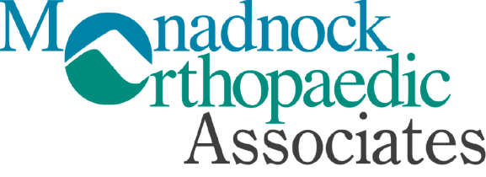
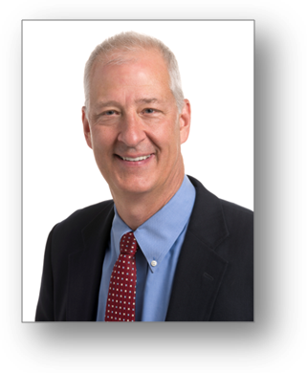
Education | Southwestern Medical School 1983
Surgical  Internship | New England Medical Center
Residency | Tufts University, Orthopaedic Residency
Fellow, American Academy of Orthopaedic Surgeons
Diplomate, American Board of Orthopaedic Surgery

W. Bradley White, M.D.
MONADNOCK COMMUNITY HOSPITAL
Arthroplasty (Total Joint Replacement)
- Hip (Mini Posterior Approach)
- Knee (Total and Oxford Uni.)
- Shoulder (Reverse and Anatomic)

Trauma / Fracture Care
- Non-Operative and Surgical Care of New Fractures and Old Fracture, Deformities
- Tendon Repairs (Hand/Wrist, Achilles, Patella, Quadriceps, Biceps)
- Ligament Repairs and Reconstructions (Knee: ACL, MCL, LCL, Patellofemoral)
- Prophylactic Stabilization and Fracture Fixation for Metastatic Bone Tumors

Tendonitis Surgery
- Tennis, Golfers Elbow
- Achilles and Other Ankle Tendons
- Hip Bursitis / Tendonitis

458 Old Street Road Suite 200 Peterborough, NH 03458 I ph 603-924-2144 fax: 603-924-3993

Arthroscopy
- Shoulder (Rotator Cuff Repair and Stabilization)
- Knee (Meniscal Repair, ACL Reconstruction and Cartilage Restoration Techniques)
- Small Joint (Ankle, Elbow)

“Why settle for debilitating pain? Advances in orthopaedic surgery and multi-modal analgesia regimens mean today’s patients recover quicker and with less pain than ever before. Patients searching for an orthopedic surgeon expect expertise and extensive experience, delivered with compassion. For 26 years, I’ve helped my patients resume their daily routines faster and more effectively than they thought possible. I’m pleased to be part of the team of experts here at Monadnock Orthopaedic Associates offering patients top-notch care, close to home.” ~Brad White, MD

Dr. White previously served for 14 years as the Team Physician for Franklin Pierce University. In the past 10 years, he has utilized his surgical expertise with World Medical Mission, as a team member with Samaritan’s Purse-Disaster Assistance Relief Team. In addition, in 2017, he treated indigenous Amazonian populations through Scalpel at the Cross, a medical missions outreach to Pucallpa, Peru.
SPECTRUM OF TREATMENTS OFFERED:
Meet your Provider ph 603-924-2144

